Figure List
PartⅠ

Chapter 1 Introduction to Ground Improvement Techniques

Fig. 1.1. Three phase diagram of soils (Ishibashi and Hazarika, 2015)
Fig. 1.2. Compaction curve (Ishibashi and Hazarika, 2015)
Fig. 1.3. Compaction curve and zero air void curve (Ishibashi and Hazarika, 2015)
Fig. 1.4. Different between compaction and consolidation
Fig. 1.5. e-logσ curve (Ishibashi and Hazarika, 2015)
Fig. 1.6. Settlement computation model
Fig. 1.7. Shear strength of a soil mass (Ishibashi and Hazarika, 2015)
Fig. 1.8. Failure strength criteria for soils (Ishibashi and Hazarika, 2015)
Fig. 1.9. Terzaghi’s bearing capacity model (Ishibashi and Hazarika, 2015)
Fig. 1.10. Model diagram of soil strength increasing mechanism (Ingles and Metcalf, 1972)
Fig. 1.11. Increasing soil strength by consolidation
Fig. 1.12. Change of soil strength by densification
Fig. 1.13. Change of soil strength by solidification
Fig. 1.14. Change of soil strength by reinforcement
Fig. 1.15. Leaning tower of Pisa, Italy (Ishibashi and Hazarika, 2015)
Fig. 1.16. Kansai international airport, Osaka, Japan (Ishibashi and Hazarika, 2015)
Fig. 1.17. Tilted buildings during Niigata earthquake, Japan (Ishibashi and Hazarika, 2015)

Fig. 1.1. Three phase diagram of soils (Ishibashi and Hazarika, 2015)

Fig. 1.2. Compaction curve (Ishibashi and Hazarika, 2015)

Fig. 1.3. Compaction curve and zero air void curve (Ishibashi and Hazarika, 2015)

- Saturated soils (b) Unsaturated soils (c) Dry soils

Fig. 1.4. Different between compaction and consolidation

Fig. 1.5. e-logσ curve (Ishibashi and Hazarika, 2015)

Fig. 1.6. Settlement computation model

Fig. 1.7. Shear strength of a soil mass (Ishibashi and Hazarika, 2015)

Fig. 1.8. Failure strength criteria for soils (Ishibashi and Hazarika, 2015)

Fig. 1.9. Terzaghi’s bearing capacity model (Ishibashi and Hazarika, 2015)

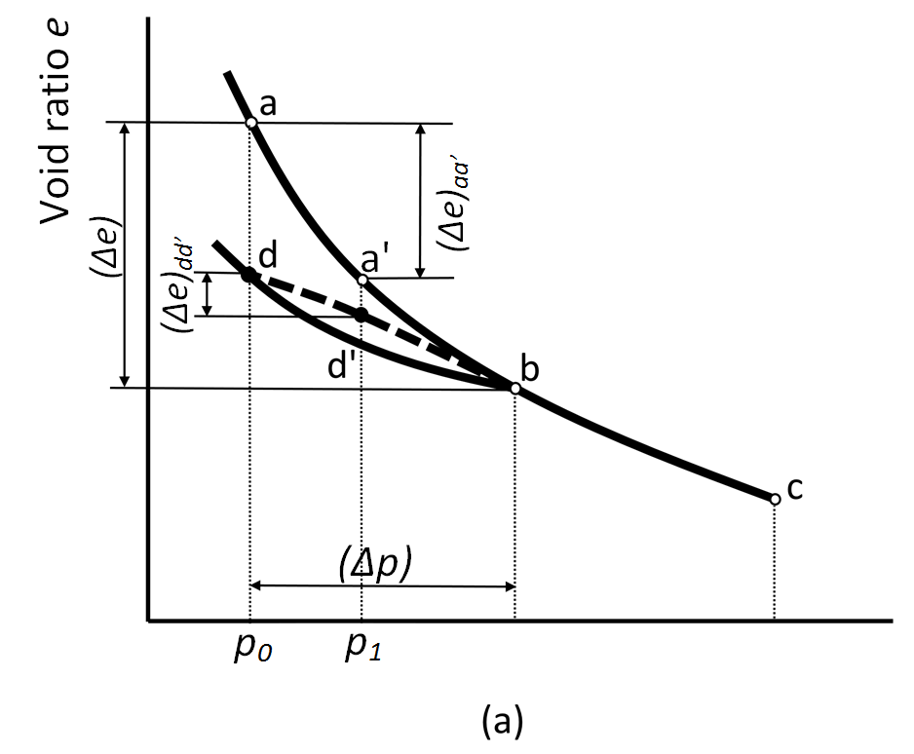
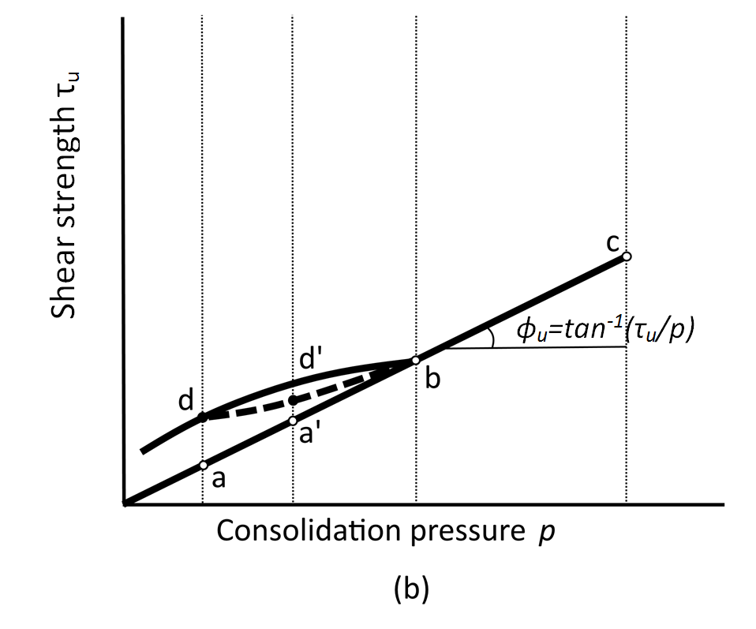
Fig. 1.11 Increasing soil strength by consolidation
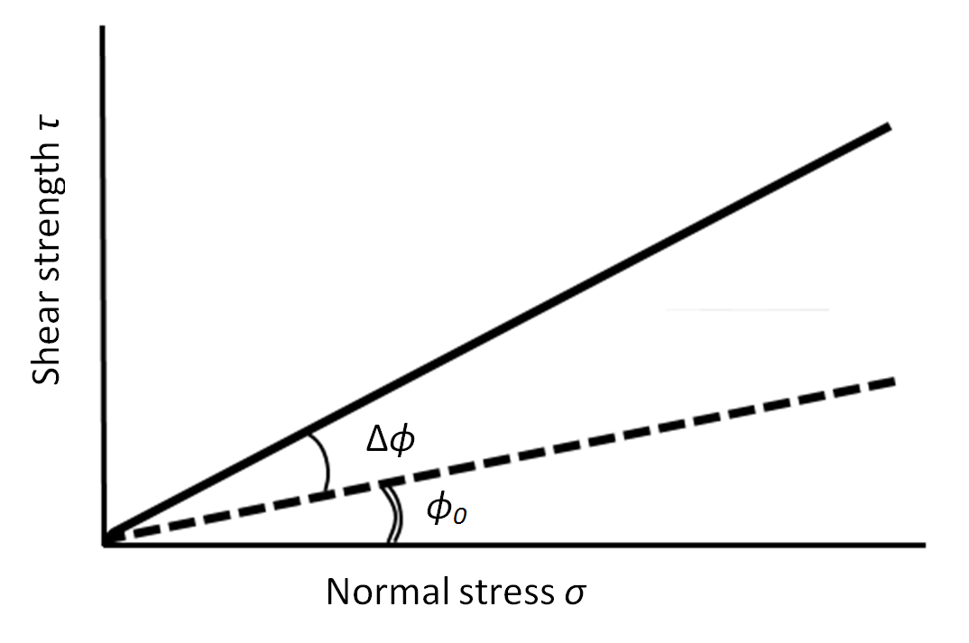

(a) φsoil
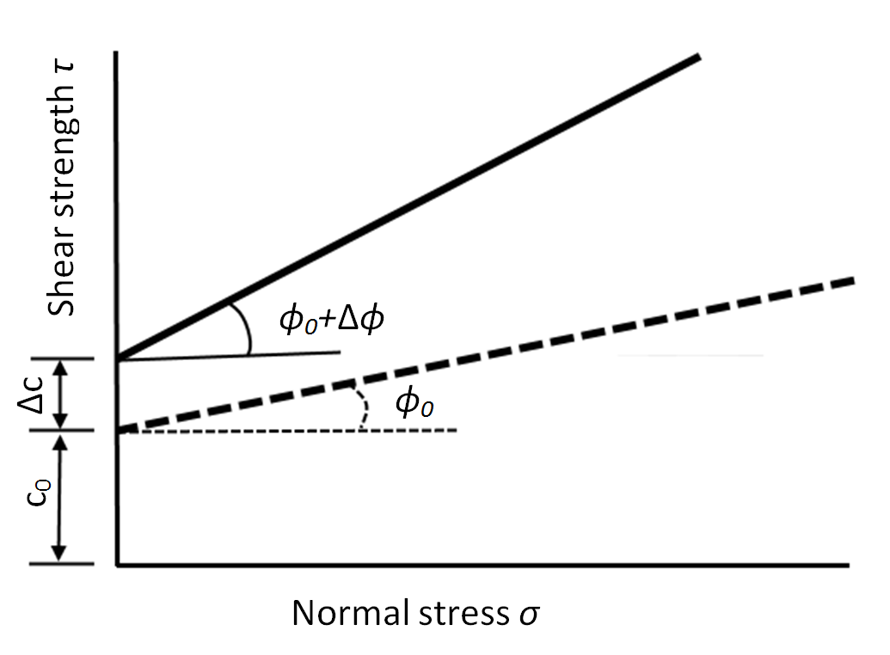
(b) c-φsoil

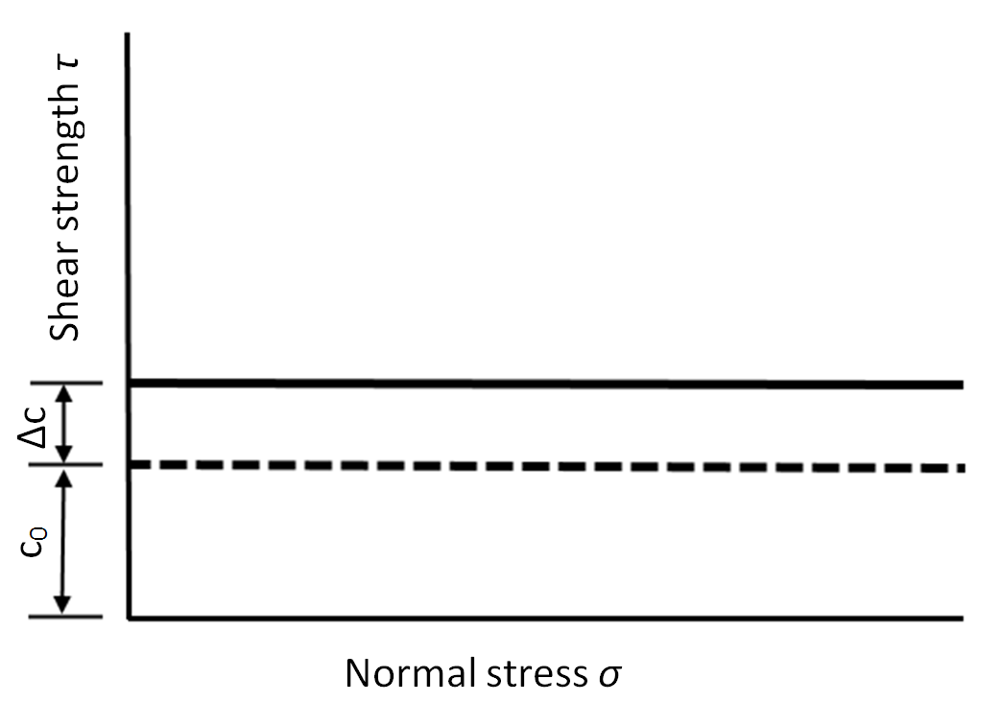
(c) c soil

Fig. 1.12 Change of soil strength by densification

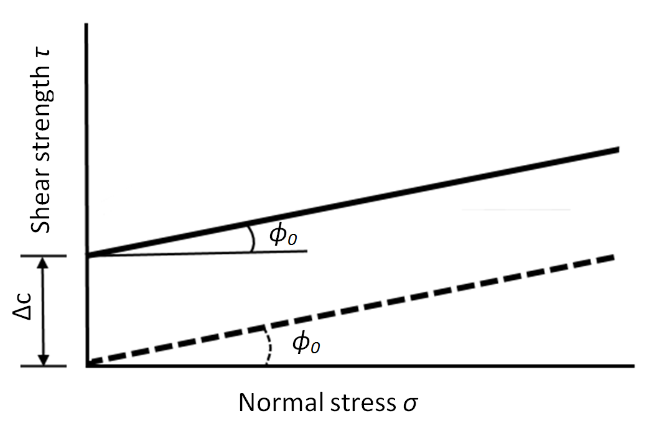
(a) φsoil

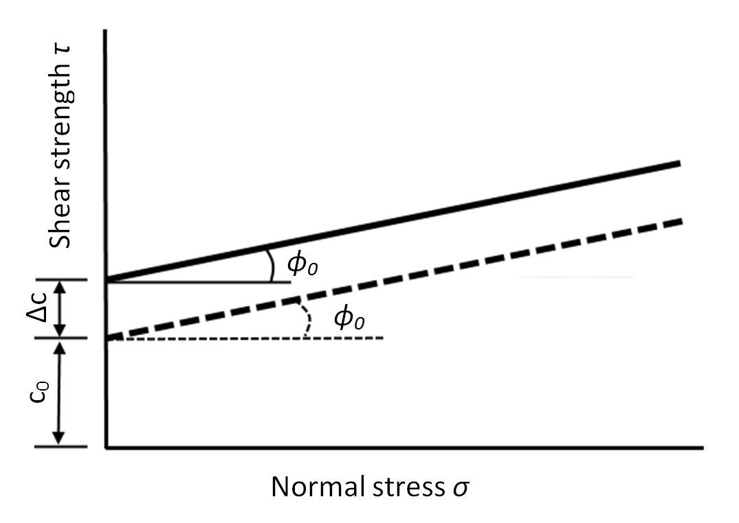
(b) c-φ soil

(c) c soil
Fig. 1.13 Change of soil strength by solidification
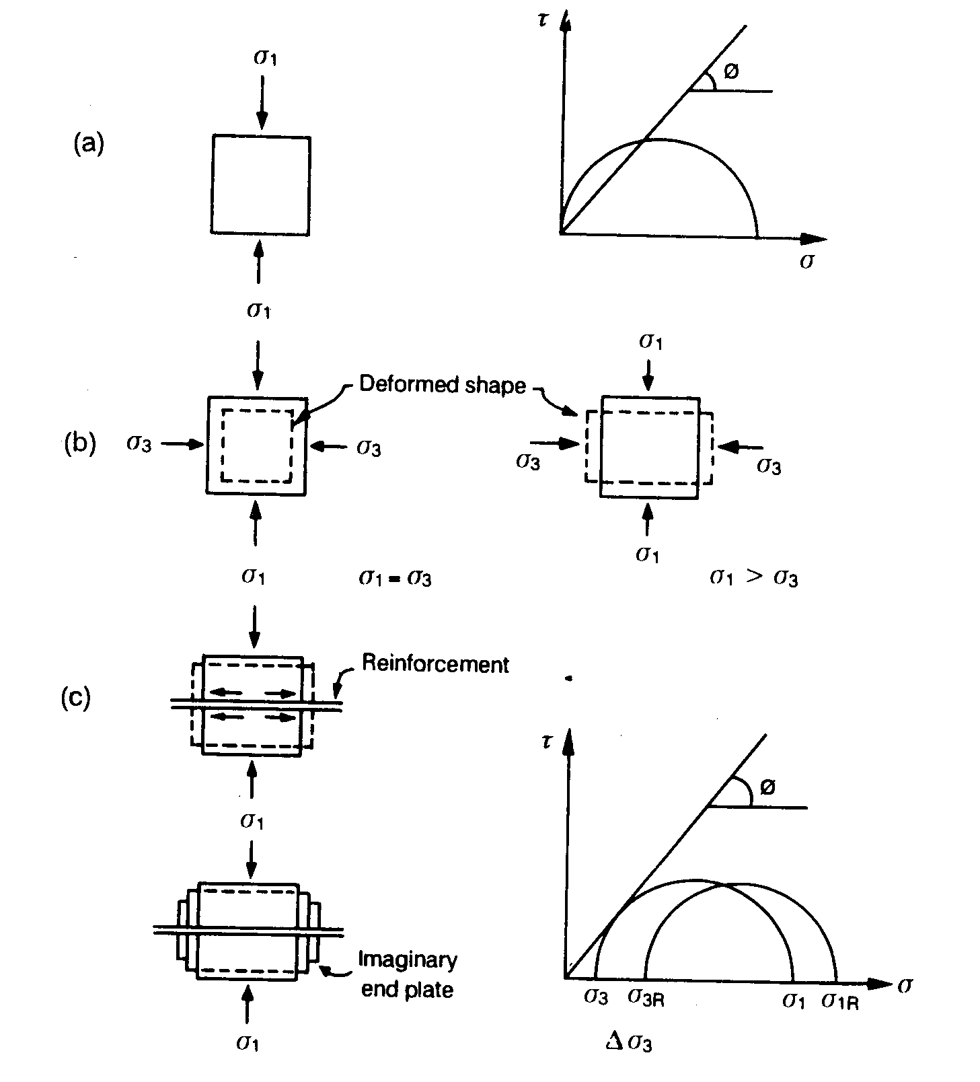

Fig. 1.14 Change of soil strength by reinforcement (Narain, J., 1984)

（ｂ）図を再構成する(学生アルバイト)

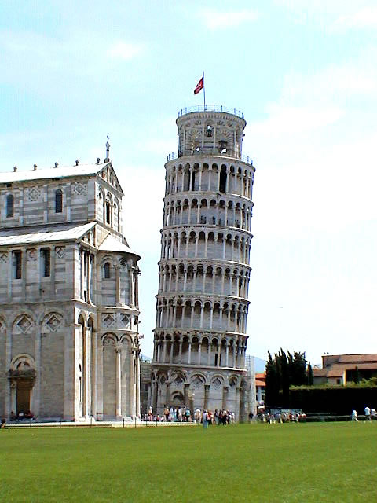

Fig. 1.15 Leaning tower of Pisa, Italy (Ishibashi and Hazarika, 2015)

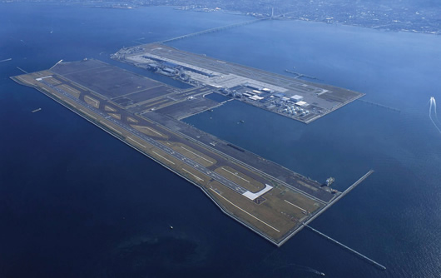

Fig. 1.16 Kansai international airport, Osaka, Japan (Ishibashi and Hazarika, 2015)

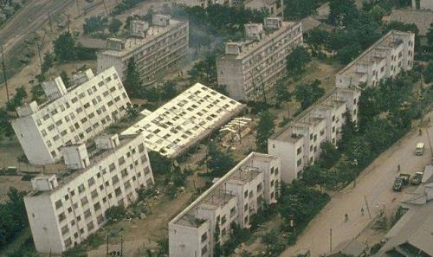

Fig. 1.17 Tilted buildings during Niigata earthquake, Japan (Ishibashi and Hazarika, 2015)
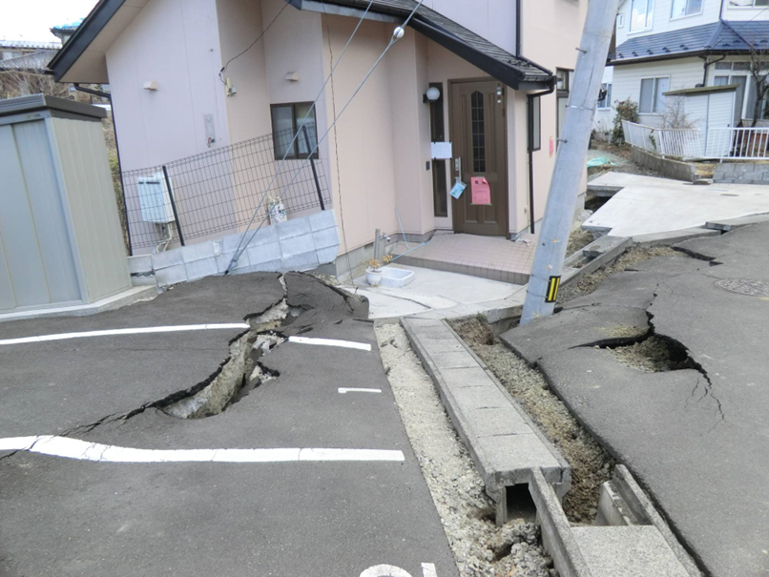
Fig. 1.18 Damaged residential house due to liquefaction induced lateral flow during 2011 Tohoku earthquake, Japan (Courtesy: Prof. Motoki Kazama, Tohoku University)

